**INDUSTRIAL UNIVERSITY OF HO CHI MINH CITY**

**FACULTY OF INFORMATION TECHNOLOGY**



GRADUATION THESIS

**USER REQUIREMENTS DOCUMENT**

SUPERVISOR: PGS.TS. HUYNH TRUNG HIEU

HO CHI MINH CITY – 01/2018

**REVISION HISTORY**

|  |  |  |  |  |  |
| --- | --- | --- | --- | --- | --- |
| **No** | **Revision date** | **Version** | **Author** | **Summary of changes** | **Reviewer** |
| 1 | Jan 25, 2018 | v01 | Huu | The first verson |  |
|  |  |  |  |  |  |
|  |  |  |  |  |  |
|  |  |  |  |  |  |
|  |  |  |  |  |  |
|  |  |  |  |  |  |
|  |  |  |  |  |  |
|  |  |  |  |  |  |
|  |  |  |  |  |  |
|  |  |  |  |  |  |
|  |  |  |  |  |  |
|  |  |  |  |  |  |
|  |  |  |  |  |  |

# table of contents

Page

Table of contents

DEFINITIONS, ACRONYMS AND ABBREVIATIONS 1

1. General description 2

1.1 Project purpose 2

1.2 Project scope 2

1.3 System context overview 2

# 

# DEFINITIONS, ACRONYMS AND ABBREVIATIONS

|  |  |  |
| --- | --- | --- |
| **No** | **Def/Acr/Abb** | **Explanation** |
| 1 | URD | User Requirement Document |
|  |  |  |
|  |  |  |
|  |  |  |
|  |  |  |
|  |  |  |
|  |  |  |
|  |  |  |
|  |  |  |
|  |  |  |
|  |  |  |
|  |  |  |
|  |  |  |

# general description

## Project purpose

This project is aimed at developing a web-based system which allows viewing and processing of DICOM images, but must ensure the security of image information.

## Project scope

The system must have the following functions:

* Viewing DICOM images
* Show image infomation
* Decentralizing users
* Have image processing functions:
* Zoom in, zoom out, rotate…

Building a web system which processes DICOM images. The system is built on Nodejs gets image data from Orthanc and processes image using Cornerstone. The doctor accesses to the site with authorities allowed.

## System context overview

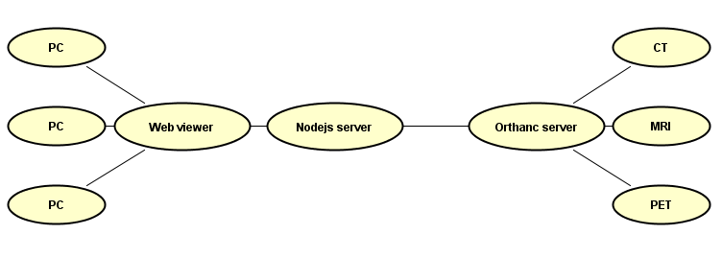

Figure 1: System context overview